2025 Report - Accessible Text Version

Current Transmissions Electrical and Computer Engineering

(2024-2025)

BY THE NUMBERS：
Electrical Engineering #72 Computer Engineering#85 U.S.
News & World Report (2025)
750+ ECE student enrollment Full-time
faculty members 34
BEST SALARIES: $83K
Missouri S&T was ranked the NO.2 public university in the U.S. for "Best Salaries" in a 2025 ranking from The Wall Street Journal and College

8 Degree Program

ELECTRICAL ENGINEERING
Bachelor of Science (B.S.) Master of Science (M.S.) Non-Thesis Master Programs (M.S.) Doctor of Engineering (Ph.D.)

COMPUTER ENGINEERING
Bachelor of Science (B.S.) Master of Science (M.S.) Non-Thesis Master Programs (M.S.) Doctor of Engineering (Ph.D.)

5 GRADUATE CERTIFICATES
#9 IN ONLINE GRADUATE PROGRAMS
Start earning college credit toward your master’s degree.
(Learn more: distance.mst.edu)

BE THE NUMBER THAT MAKES A DIFFERENCE!
No matter how we convey our gratitude, we thank you for making a difference.


Letter from Department chair
Dear Friends and Colleagues,
As I write this, the Fall 2025 semester is about to start. The freshmen have arrived, full of hope and excitement as they start the next phase of their lives. Upperclassmen are trickling in, returning from internships that will advance their careers. New graduate students are arriving for orientation, ready to grow their skills and knowledge as they advance their respective fields. Last year, we celebrated our centennial as a standalone department offering electrical engineering degrees. This year, we continue to offer both electrical and computer engineering degrees at bachelor’s, master’s, and doctoral levels, and are partnering with two other departments to offer a bachelor’s degree in semiconductor engineering. Headquartered in Material Science & Engineering and partnering also with Chemical & Biochemical Engineering, this new program will provide students the opportunity to learn about semiconductor device manufacturing and design. This is an important expansion and modernization of our offerings. The first faculty member in the program, Feng Zhao, is a professor of ECE specializing in semiconductor device design and fabrication, particularly wide bandgap devices. In these pages, you will read about our many distinguished students, faculty, and staff. I am proud to be starting my fourth year leading such a highly-regarded department. Both undergraduate and graduate students have been recognized for their achievements in the classroom and the lab. Our faculty are known for both teaching and research prowess and continue to push the state of the art in many areas. We rely on our excellent staff to keep the department running smoothly. As a department and institution, we serve future alumni. You will read here about just a few of our many distinguished alumni, including a new member of the National Academy of Engineering. I eagerly anticipate the great things that today’s students will achieve as they continue to reflect our department’s legacy of excellence. Best Regards
Jonathan W. Kimball Ph.D., P .E.
Fred W.
Finley Distinguished Professor Chair of Electrical and Computer Engineering
Table of Contents
Highlights 5
My journey into Electrical and Computer Engineering 5
Faculty Achievements 9
Dr. Rui Bo Secures $750,000 DOE Grant and Named Kummer Impact Professor 9
Dr. Joe Stanley awarded $440,000 from NIH for skin cancer detection research 11
SIX ECE FACULTY HONORED AT MISSOURI S&T FACULTY AWARDS CEREMONY 13
TICHENOR RECEIVES TEAM IMPACT AWARD 14
TWO ECE FACULTY MEMBERS NAMED 2025 TENURED FACULTY HONOREES AT MISSOURI S&T 15
Students Successes 17
ECE DOCTORAL STUDENT WINS TWO BEST PAPER AWARDS AT DESIGNCON 2025 17
FOUR ECE STUDENTS AWARDED IEEE PES SCHOLARSHIPS 18
FIVE ECE PH.D. Students Honored WITH DEAN’S AWARDS FOR EXCELLENCE 19
Students Excel at IEEE Region 5 Conference 21
Alumi News 22
Patrick L. Chapman Elected to National Academy of Engineering 22
FOUR ALUMNI INDUCTED INTO THE ACADEMY OF ELECTRICAL AND COMPUTER ENGINEERING 24
MISSOURI S&T’S ELECTRICAL ENGINEERING DEPARTMENT MARKS 100 YEARS 28
Welcome Our New Faculty 29

Highlights

My journey into Electrical and Computer Engineering
  - Ruijie He's story :Ruijie He earned his Ph.D.from ECE in 2022 and is currently working as a Chip Packaging Design Engineer at Apple.
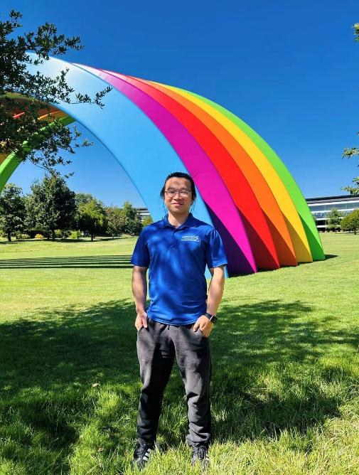
My journey into the world of Electrical and Computer Engineering didn’t begin with a complex theory—it began with a moment of pure magic. During a circuit experiment in my undergraduate years at Huazhong University of Science and Technology (HUST), I noticed something fascinating: a loose wire hovering over a development board could trigger different tones from a speaker. I was so captivated that I managed to “play” a simple version of Twinkle, Twinkle, Little Star just by moving the wire.
It wasn’t until my microwave engineering class that I had my “Aha!” moment: what I thought was magic was actually Electromagnetic Interference (EMI). That realization transformed my curiosity into a scientific passion.
This passion was further ignited by two key courses— Microwave Engineering and High-Speed Digital Circuit Design. These courses opened my eyes to the intricate world of signal integrity and electromagnetics. The idea of solving real-world problems in high-speed systems through simulation, calculation, and hands-on experimentation was exhilarating. My path became clear when a professor, who had been a visiting scholar at Missouri S&T, mentioned that Missouri S&T had the world’s top EMC lab. That one sentence planted a seed.
Eager to see it for myself, I applied for a summer internship at Missouri S&T. The experience was transformative. It wasn’t just the state-of-the-art equipment that impressed me—it was the culture. Faculty and students shared a deep commitment to learning by doing, which resonated with my own undergraduate experience in a special “seed class” focused on hands-on growth. I knew then that Missouri S&T was the perfect place to pursue my Ph.D.
  - Fond Memories of Missouri S&T
From the start of my Ph.D.in 2015 to graduation in 2022, my time at Missouri S&T was filled with both intense challenges and profound rewards.
One of my most vivid memories is from the RF Design course, where we were tasked with building a PAM-4 signal generator using the most cost-effective components available, aiming to match the bit rate of commercial devices. It was a brutal but brilliant lesson. Designing a 14GHz high-speed circuit is an entirely different world from standard electronics; even the smallest soldering flaw could wreak havoc on the waveform. Our professor was our anchor—he believed in us, taught us theory, and even gave us hands-on lessons in the art of perfect soldering. The pride we felt when our system finally worked, and we presented it to the class is unforgettable. We often left the lab as the sun was rising, only to head straight to morning lectures. It was intense—but that’s what the quintessential Missouri S&T experience is: pushing you to your limits so you can discover just how far you can go.
If the lab represented Missouri S&T’s academic rigor, the annual Celebration of Nations represented its heart. As a lifelong map enthusiast, I could name every country and recognize its flag—but that festival brought those flags to life. For the first time, I saw them waving in the hands of real people, each representing a story, a voice, a culture. I immersed myself in the festivities, tasted foods from around the world, and chatted with students in the parade. When I shared what little I knew about their countries, their excitement was infectious. It was a beautiful, living example of harmony in diversity.

From Campus to Career
Today, I work as a Chip Package Design Engineer at Apple. My role is to design chip packaging that ensures high-speed and RF circuits perform flawlessly. What I love most is shaping a design from its earliest stages and navigating the complex trade-offs involved.
My education at Missouri S&T provided me with a deep foundation in high-speed circuit theory, RF design, and EMI desense issues. That training serves as an internal “radar” that helps me anticipate and solve problems before they arise. When performance specifications conflict, I’m equipped to find the most rational, effective compromise. There’s tremendous satisfaction in knowing the work I do contributes to products that people use and love every day.
The challenges are real—circuit frequencies continue to rise, form factors keep shrinking, and constraints are tighter than ever. But that’s also what makes the work so rewarding. It's a lot like my favorite hobby, rock climbing: every move is a balance of strength, skill, and strategy. In both climbing and engineering, I find joy in the challenge—and even more in the triumph.
  - Advice for future Students
If I could offer some advice to current and future Missouri S&T students, it would be these three things:
Seize every chance to get your hands dirty. Missouri S&T provides invaluable opportunities for hands-on practice. Actively seek them out, especially projects that involve collaboration with industry engineers. This will broaden your perspective and ground your knowledge in real-world applications.
In the age of AI, expand your intellectual horizons. The entry points to knowledge are more accessible than ever. Don't confine yourself to a single domain. Gain a foundational, "entry-level" understanding of various fields. Once you have that key, you can leverage AI to accelerate your learning in any direction. The breadth of your knowledge truly determines the height of your potential.
Proactively develop your communication skills. The ability to clearly describe a technical problem and effectively "advertise" your research is just as critical as your technical expertise.
Don't be shy. Take the initiative to organize study groups and volunteer to draft and deliver presentations. Every time you do this as a student, you are paving the road for your future career success.
Alumni who wish to share their own stories are invited to email bma@mst.edu.

Faculty Achievements

Dr. Rui Bo Secures $750,000 DOE Grant and Named Kummer Impact Professor
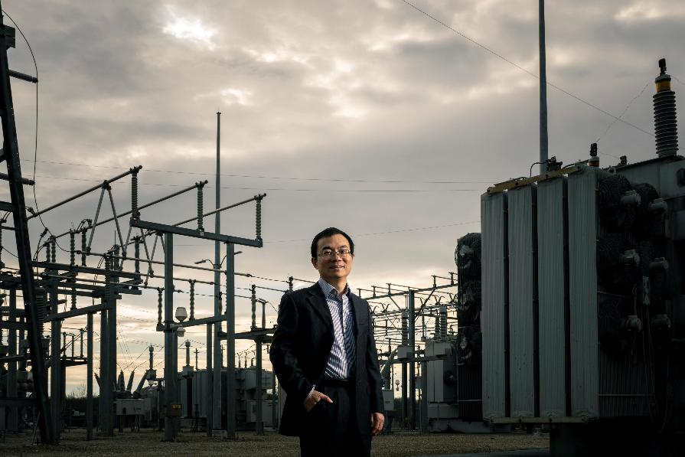
Dr.Rui Bo stands in front of a power station.
"I look forward to making lasting contributions to our field and enhancing our institution’s national standing."
Dr. Rui Bo, an associate professor of electrical and computer, is making waves in the fields of hydropower and energy systems. He was recently awarded a $750,000 grant from the U.S. Department of Energy (DOE) and also named a Kummer Impact Professor, recognizing both his groundbreaking research and leadership in academia.
The DOE grant will fund Dr. Bo’s research to improve short-term scheduling for hydropower plants by developing a hydropower co-optimization tool that integrates detailed models of water and energy constraints.
His work will support more efficient, reliable integration of hydropower into the modern electric grid, which increasingly relies on intermittent renewable resources like solar and wind.
Dr. Bo’s project is one of nine selected nationwide in the DOE’s Water Power Technologies Office initiative to advance hydropower modeling.
In recognition of his achievements and potential for long-term impact, Missouri S&T has named Dr. Bo a Kummer Impact Professor, a prestigious appointment that supports faculty who are shaping the future of STEM education and research.
The Kummer designation includes funding to support research, student mentoring, and innovation.
Dr.Bo joined Missouri S&T in 2017. His research interests include power system modeling, optimization, cyber-physical systems, and renewable energy integration. He has published extensively and collaborated with national labs and industry partners to drive innovation in electric grid operations.

Dr. Joe Stanley awarded $440,000 from NIH for skin cancer detection research
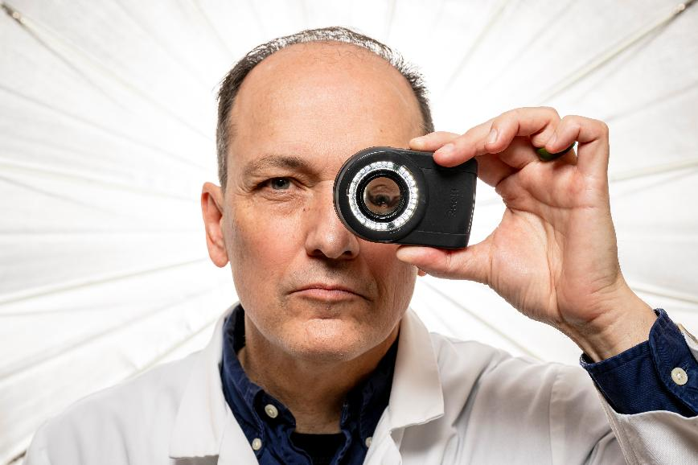
Dr. Joe Stanley uses the skin cancer detection.
Dr. Joe Stanley, is working to improve the detection of skin cancer, and he was recently awarded a $440,000 grant from the National Institutes of Health to support his efforts.
“When skin cancer is detected early, it can be more effectively treated,” says Dr. Joe Stanley. “The publicly available dataset our research team is developing will help experts better do their jobs and make more informed diagnostic decisions.” For the three-year project, Stanley’s team will use tens of thousands of images already available through the International Skin Imaging Collaboration.
Researchers will label and annotate skin lesions and other important features for detection, incorporate machine learning elements into the database, and analyze statistics related to the different features.
“Datasets already exist for skin cancer research, but they are all limited in scope or privately owned,” Stanley says. “What separates our work is the number of expert-driven details we will include, which will provide much more context for the imaging.
Experts will be more involved in the process and provide the best information to guide the project’s machine learning aspects.” He says the database will be something medical doctors will use for training purposes, so they can be more informed on the different attributes that can be found with skin cancer.
Doctors will be better suited to conduct dermoscopies, or magnified inspections of the skin, and know what lesions and other attributes may be early signs of skin cancer. The platform will also be available for other skin cancer researchers to use for their work.
Dr.V .A. Samaranayake, a Chancellor’s Professor of mathematics and statistics, is a co-principal investigator on the research team.
Other researchers involved with the project include Dr. William Van Stoecker, a dermatologist with The Dermatology & Aesthetic Center in Rolla, Missouri, and research scientist and CEO of S&A Technologies; Dr. Mirna Becevic, an assistant professor of dermatology at the University of Missouri School of Medicine, and Dr. James Grichnik, professor and chair of dermatology and cutaneous surgery at the University of South Florida.

SIX ECE FACULTY HONORED AT MISSOURI S&T FACULTY AWARDS CEREMONY
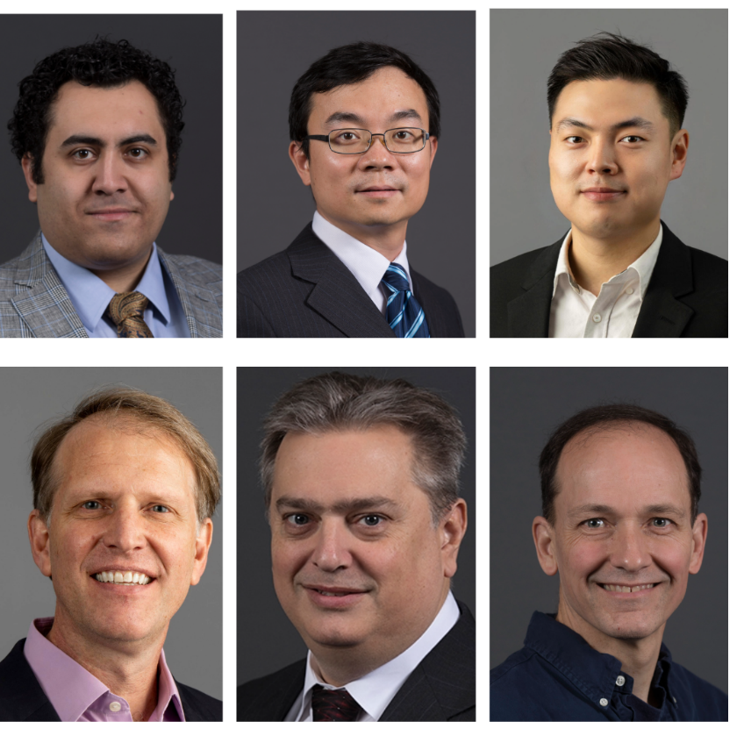
Six faculty members from the ECE Department were recognized for their outstanding contributions during the university’s recent Faculty Awards Ceremony.
Honorees included:
•Dr. Pourya Shamsi , recipient of the Faculty Teaching Award
•Dr.Rui Bo , recipient of the Faculty Research Award
•Dr.DongHyun “Bill” Kim , recipient of the Faculty Research Award
•Dr.Daryl Beetner , recipient of the Faculty Research Award
•Dr.Bob Woodley , recipient of the Fac - ulty Achievement Award
•Dr.R.Joe Stanley , recipient of the Faculty Teaching Award

TICHENOR RECEIVES TEAM IMPACT AWARD
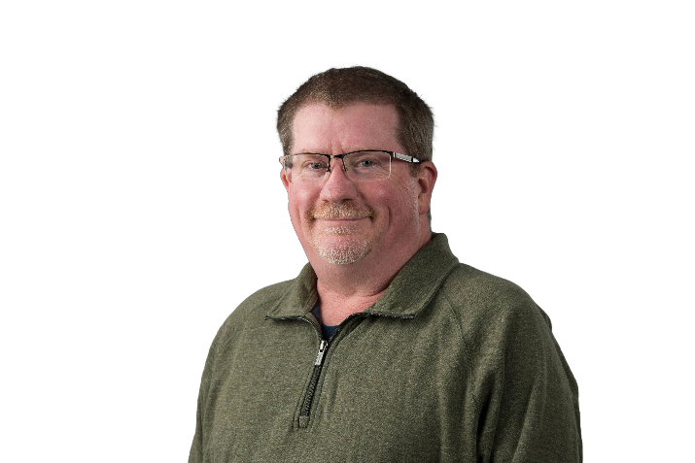
Jerry Tichenor, research technical services supervisor in the electrical and computer engineering department at Missouri S&T, was honored with the Team Impact Award during the university’s College of Engineering and Computing Fall 2024 awards ceremony. The event, held at the Havener Center, celebrated the achievements of outstanding - ing staff and faculty across the college.
The Team Impact Award recognizes staff members who have demonstrated exceptional collaboration and teamwork to achieve significant outcomes.
Tichenor’s dedication and contributions to the ECE department have made a meaningful difference, showcasing his commitment to excellence and innovation in technical services.

TWO ECE FACULTY MEMBERS NAMED 2025 TENURED FACULTY HONOREES AT MISSOURI S&T
Dr.Daryl Beetner and Dr.Jagannathan Sarangapani, both faculty members in Missouri S&T’s Department of Electrical and Computer Engineering, have been named among the university’s nine Tenured Faculty Honorees for 2025 .
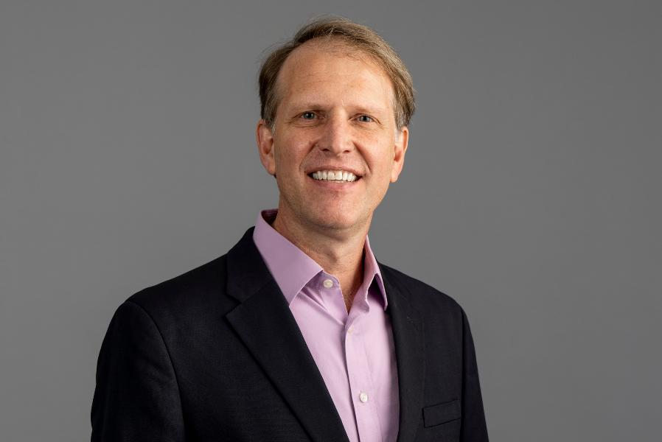
Dr.Daryl Beetner has been a driving force at Missouri S&T since 1998, an IEEE Fellow (2024) recognized interna ‑ tionally for his work in electromagnetic compatibility, high‑speed circuit de ‑ sign, and biomedical applications, he has published 73 journal papers and 140 conference papers, secured more than $35 million in sponsored research (with over $8 million as principal in ‑ vestigator), and mentored 51 graduate students. Beetner’s leadership has forged collaborations with Apple, Google, Intel, Cisco, Amazon, and dozens of other industry partners, making him a catalyst for interdisciplinary research and real‑world impact in the field.
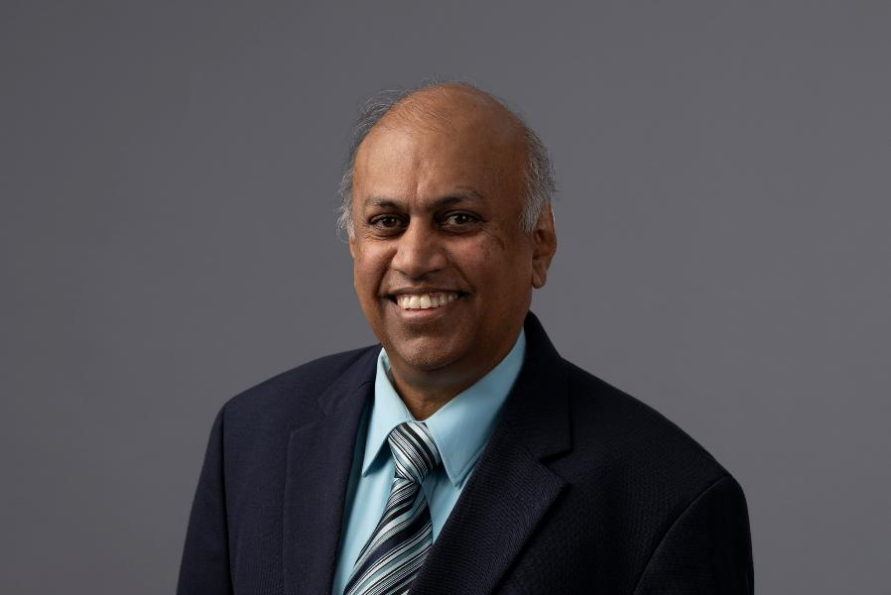
Dr.Jagannathan (Jag) Sarangapani, as the Curators’ Distinguished Professor and Rutledge‑Emerson Endowed Chair in Electrical and Computer Engineering, is internationally recognized for his ground-breaking work in intelligent control, robotics, autonomous systems, and secure cyber‑physical systems.
A Fellow of IEEE, the National Academy of Inventors, and several other prestigious organizations, he has secured over $47 million in total research funding (with nearly $14 million as principal investigator), published extensively, and mentored numerous students and junior faculty. His leadership has left a lasting imprint across engineering disciplines and global research networks.

Students Successes

ECE DOCTORAL STUDENT WINS TWO BEST PAPER AWARDS AT DESIGNCON 2025
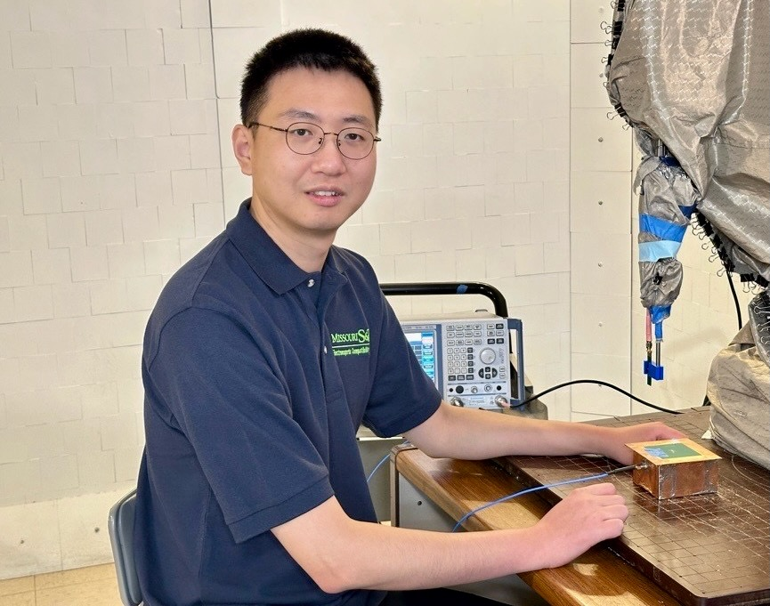
Hanyu Zhang, a doctoral student in electrical engineering at Missouri S&T, received both the Best Paper Award and the 2025 Early-Career Best Paper Award at DesignCon 2025 for his research on power integrity in modern electronics.
His paper, “A Parameter Extraction Method for Multi-Phase Buck Converters Based on Nonlinear Least Square Method,” was co-authored by Junhu Joo, Wenchang Huang and Chulsoon Hwang of Missouri S&T, along with Hanfeng Wang, Wei Shen, Zhigang Liang, Lihui Cao and Seungtaek Jeong from Google.
“Receiving this award is a great honor and recognition of my efforts in VRM modeling,” Zhang said. “It validates the impact of my research and inspires me to continue exploring innovative ideas.” Zhang earned his bachelor’s and master’s degrees in electrical engineering from Southwest University of Science and Technology in China.
He is pursuing his Ph.D.at Missouri S&T’s Electromagnetic Compatibility Laboratory, focusing on power integrity and electromagnetic interference in power electronics systems.
He plans to develop new methodologies to improve system reliability and advance research in power integrity for next-generation technologies.

FOUR ECE STUDENTS AWARDED IEEE PES SCHOLARSHIPS
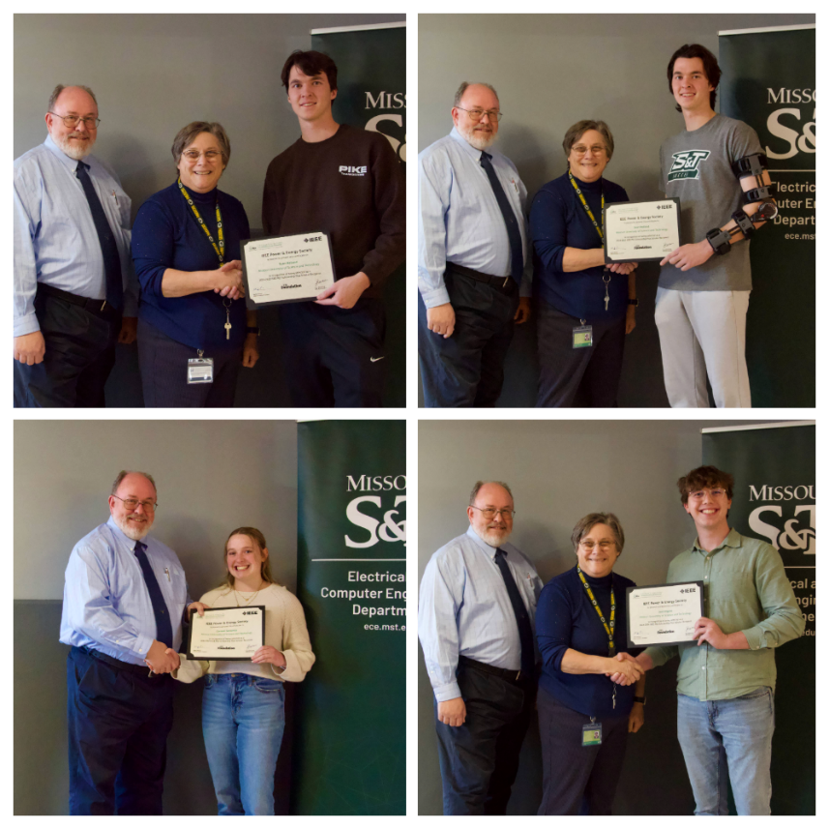
Four electrical and computer engineering students at Missouri S&T have been awarded the IEEE Power & Energy Society (PES) Scholarship for the 2024-25 academic year.
The scholarship recognizes undergraduate students who demonstrate academic excellence, leadership, and a commitment to the power and energy field.
Scholarship recipients: Ryan Holland, junior in electrical engineering Sean Holland, junior in electrical engineering; Carmen Gassaway, senior in electrical engineering Joel Kilgore, senior in electrical engineering. The IEEE PES Scholarship Plus Initiative supports students pursuing careers in power and energy engineering, fostering the next generation of professionals in the field.
Scholarships are awarded based on academic performance, extracurricular involvement, and a demonstrated commitment to the energy sector.

FIVE ECE PH.D. Students Honored WITH DEAN’S AWARDS FOR EXCELLENCE
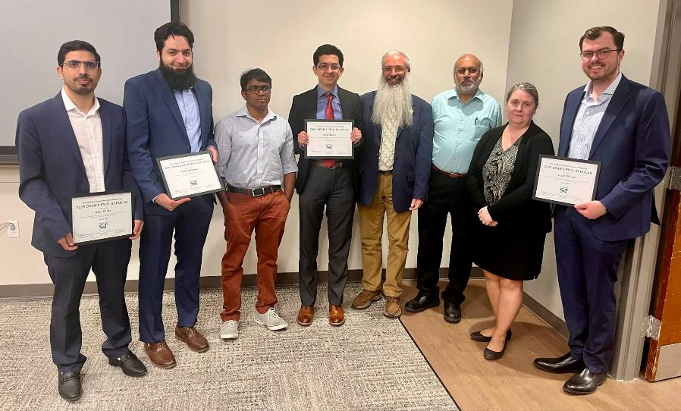
Five doctoral students from ECE Department were recognized with prestigious honors from the College of Engineering and Computing (CEC) during a ceremony held in early May.
Three students — Irfan Ganie, Omar Rinchi, and Logan Wilcox — received the Dean’s Ph.D.
Scholar Award, which recognizes outstanding scholarly contributions by some of the most productive Ph.D. students across the college.
Two students — Raghu Yelugam and Ehab Rahman — were awarded the Dean’s Graduate Educator Award, which highlights excellence in teaching among graduate students.
“These five awardees exemplify the academic excel - lence, research leadership, and teaching impact that define our graduate program,” says Dr. Daryl Beetner, Director of the Center for Electromagnetic Compatibility. “We’re proud to see their hard work and dedication recognized at the college level.”
ECE Award Recipients Dean’s Ph.D.Scholar Award:
• Irfan Ganie – Nominated by Dr. Jagannathan Sarangapani, Curators’ Distinguished Professor and Rutledge-Emerson Professor of ECE
• Omar Rinchi – Nominated by Dr. Ahmad Alsharoa, assistant professor of ECE
• Logan Wilcox – Nominated by Dr. Kristen Donnell, Woodard Associate Professor of Excellence in ECE Dean’s Graduate Educator Award :
• Raghu Yelugam – Nominated by Dr. Theresa Swift, teaching professor of ECE
• Ehab Rahman – Also nominated by Dr. Theresa Swift Award recipients were selected through a competitive two-step process.
Each department within CEC nominated up to three candidates per category, followed by final selections made by a committee of five faculty members from across the college.
“These honors underscore the ECE department’s commitment to fostering world-class researchers and educators,” Beetner adds. “We look forward to the continued success of these outstanding individuals.”

Students Excel at IEEE Region 5 Conference
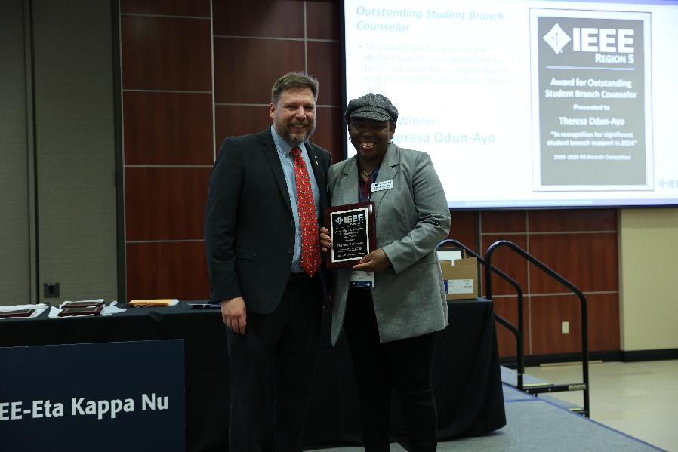
Students from Missouri S&T and Missouri State University (MSU) earned multiple awards at the IEEE Region 5 Annual Conference, held in Wichita, Kansas.
Competing in categories including circuits, robotics, 3M- T (Three Minute Thesis), cybersecurity and ethics, the students showcased technical excellence, innovation, and teamwork.
Missouri S&T’s Rotimi Olugbemi placed second in the Three Minute Thesis competition, while Ben Cuebas and Justin Fausto earned third place in the Circuits Competition.
Daniel Odun-Ayo placed fourth in the Three Minute Thesis, and Anneli De Rousse and Charles Price took fourth in the Ethics Competition.
Ben Cuebas also received the IEEE Region 5 Outstanding Student Award, and Dr.
Theresa Odun-Ayo was honored with the Outstanding Student Branch Counselor Award.
“We are incredibly proud of our students’ hard work and achievements,” said university representatives.
“Their success reflects the strength of our engineering and computer science programs.” IEEE Region 5 encompasses a five-state area and includes over 23,000 members in more than 90 student and professional branches.
The annual conference brings together students, faculty, and professionals to engage in technical competitions, workshops, and networking opportunities.

Alumi News

Patrick L. Chapman Elected to National Academy of Engineering
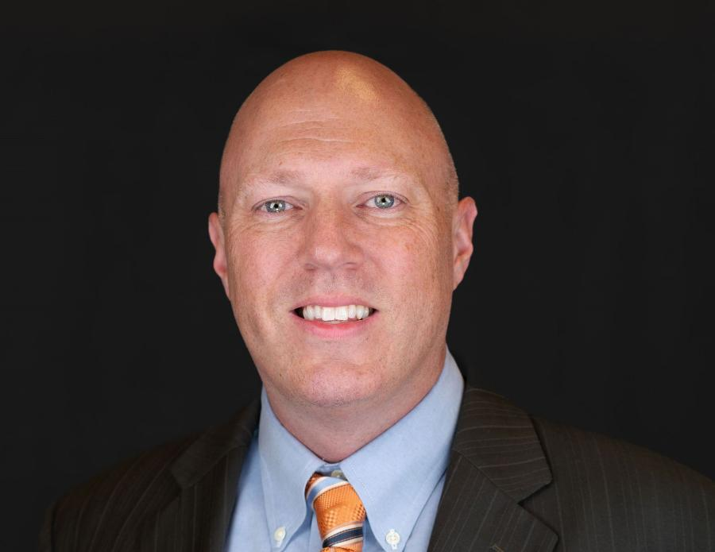
Dr.Patrick Chapman. Photo courtesy of Chapman.
“As an S&T student, I gained so many valuable experiences and an education with an amazing return on investment.”
If a home in the United States has rooftop solar panels, there’s a strong likelihood that Dr. Patrick Chapman, a Missouri S&T ECE alumnus, played a role in developing its power inverters. In recognition of his contributions, he was recently elected to the National Academy of Engineering.
“I feel deeply honored and grateful to be elected to the academy,” Chapman says. “The opportunities I’ve had throughout my career, along with the incredible people I’ve worked with, have been crucial to my success. As a new member, I intend to continue promoting the field of engineering and helping others see how our work can make a real difference in the world.” Chapman, who earned two degrees from Missouri S&T — a bachelor’s degree in electrical engineering in 1996 and a master’s degree in the same field a year later — says it was during his time at S&T that his passion for power electronics was first sparked.
“When I first came to S&T, I was actually interested in computer science, but by my sophomore year, I realized the hands-on work electrical engineers do with hardware was a better fit for me,” says Chapman, a Centralia, Missouri, native who now lives in Austin, Texas. “I was able to conduct undergraduate research focused on power electronics, and my research advisor, Dr. Scott Sudhoff, encouraged me to continue this research as a graduate student.”
After earning his two S&T degrees, Chapman followed Sudhoff to Purdue University. In 2000, Chapman earned a Ph.D. in electrical engineering.
Around 2006, Chapman and his colleagues pivoted the SmartSpark Energy Systems battery management startup company that Chapman co-founded in 2003 to instead develop micro-inverters attached to solar panels that convert direct current (DC) power from the panels into alternating current (AC) for homes.
At first, his role with this company, which was eventually renamed Solar Bridge Technologies, was part-time. But in 2010, he left his Illinois professorship and took on a full-time role.
Since then, he has continued to work in industry roles, and he is currently CEO of Stormentum — a startup he recently founded to develop solutions for combining battery storage with solar power systems.
To go along with this NAE membership, Chapman has several other accolades to his name, including approximately 75 U.S. patents, over 100 academic papers published, Fellow status for the Institute of Electrical and Electronics Engineers, and membership in Missouri S&T’s Academy of Electrical and Computer Engineering.
He says his time at Missouri S&T helped set the wheels in motion for these accomplishments.
“Missouri S&T is a phenomenal school for students who are eager to learn and have a maker mentality,” he says.“When I came to Rolla from my small town, until then, I was a bookworm and didn’t have much hands-on experience.

FOUR ALUMNI INDUCTED INTO THE ACADEMY OF ELECTRICAL AND COMPUTER ENGINEERING
The Department of Electrical and Computer Engineering at Missouri University of Science and Technology welcomed four distinguished alumni into the Academy of Electrical and Comput - er Engineering during its annual meeting on April 10.
This year’s inductees are Andy Bonnot, Ryan Bales, Don McIntosh, and Dan Nobbe. Their induction honors decades of leadership, innovation, and service in the field of electrical and computer engineering, as well as their continued support of the department.
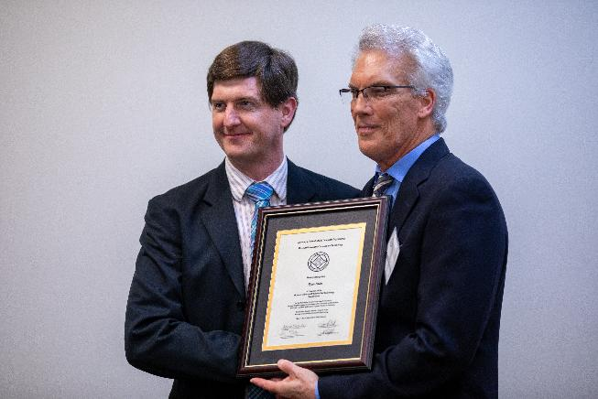
Ryan Bales holds a B.S. and M.S. in engineering from Missouri S&T and a Ph.D. in electrical and computer engineering from Georgia Tech. He is a principal research engineer at the Georgia Tech Research Institute and serves as chief lead signal processing firmware engineer. An IEEE Senior Member, Bales has held multiple leadership roles within IEEE-HKN and the AESS/GRSS Atlanta Joint Chapter.

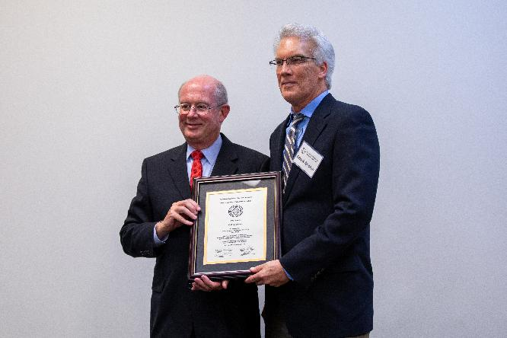
Andrew Bonnot earned both his B.S. (1982) and M.S. (1983) degrees in electrical engineering from Missouri S&T. Over a 30-year career with Raytheon and Texas Instruments, he held leadership roles in microwave design, radar systems, and airborne electro-optic and infrared technologies, managing product lines with annual sales exceeding $750 million. Following his retirement in 2015, Bonnot returned part-time as a program manager, developing training for high-potential leaders.
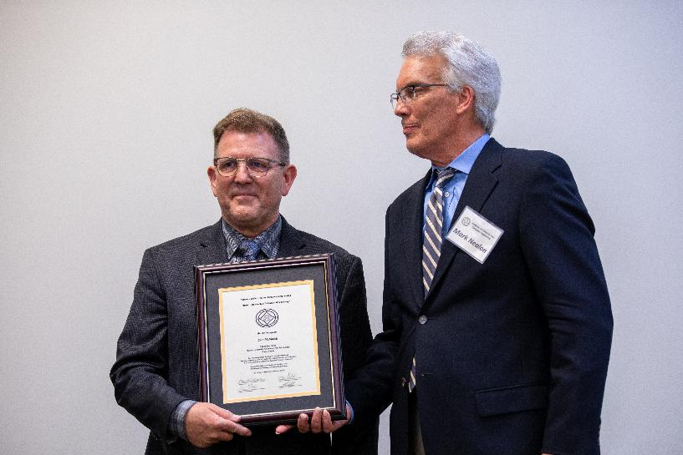
Don McIntosh earned his B.S. in electrical engineering from Missouri S&T in 1982. A serial entrepreneur and technology leader, he has founded and led multiple companies over four decades, including CIMware, Gnosis Management, and currently Sky Peak Technologies, where he serves as president, CTO, and co-founder. His diverse experience spans power utilities, aerospace electronics, software architecture, and startup incubation.
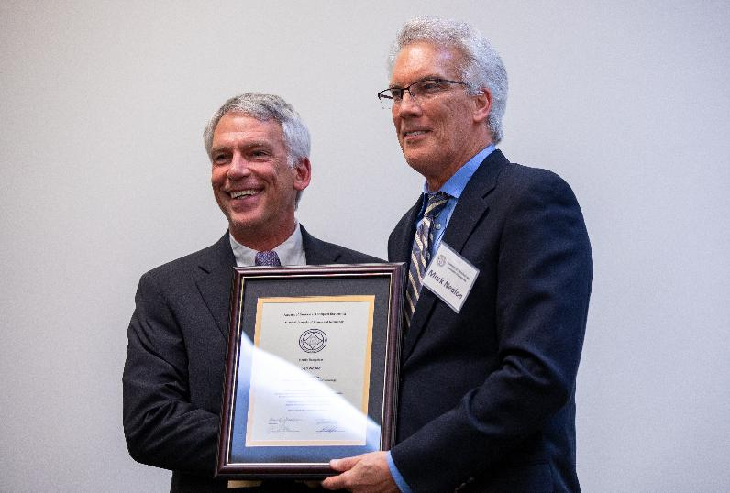
Dan Nobbe earned a B.S. in electrical engineering from Missouri S&T in 1989 and an M.S. from the University of Texas at Arlington in 1994. He has over three decades of experience in RF and semiconductor industries, holding leadership roles at pSemi, Motorola, and Glenayre. Currently serving as vice president of RF and radar systems at MatrixSpace, Nobbe also contributes as president of Skeyeon's expert advisory board.

MISSOURI S&T’S ELECTRICAL ENGINEERING DEPARTMENT MARKS 100 YEARS
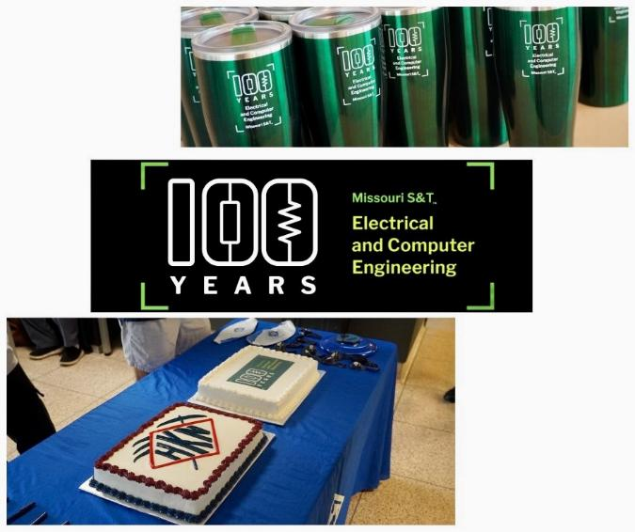
Missouri S&T’s electrical and computer engineering (ECE) department celebrated its 100th anniversary during Homecoming 2024, marking a century of innovation and growth.
Established in 1924, the department began when the university was known as the Missouri School of Mines and Metallurgy, with just 353 students enrolled campus-wide. Today, the ECE department alone serves hundreds more students than the entire university did at its founding. According to university historian Dr. Larry Gragg, courses related to electricity date back to 1876, with the first dedicated class offered in 1891. The program officially became a department in 1924 after years of development and legislative support, including the 1915 Buford Act.
The centennial celebration honored the department’s rich history and welcomed alumni and guests back to campus.
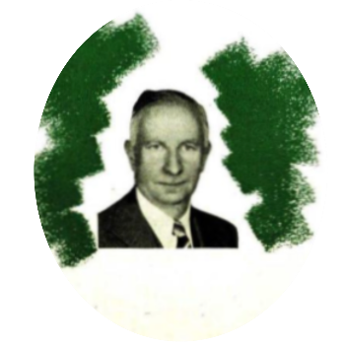
Dr.Floyd H. Frame was Missouri S&T’s founding chair of electrical engineering, serving in the role

Welcome Our New Faculty
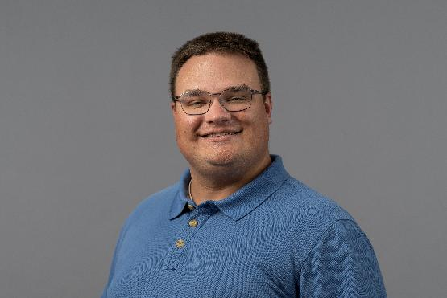
Dr.Jakob DeLong --- Assistant Teaching Professor
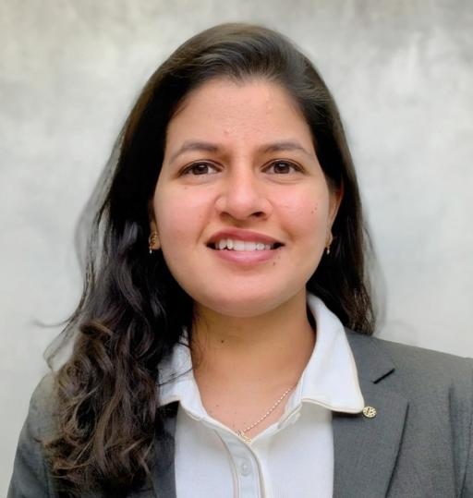
Dr. Shruti Pandey --- Assistant Teaching Professor
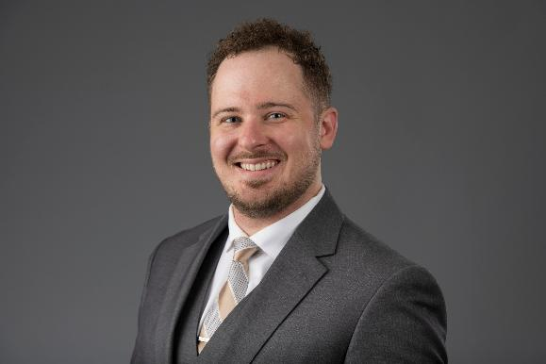
Dr. Sasha Petrenko --- Assistant Research

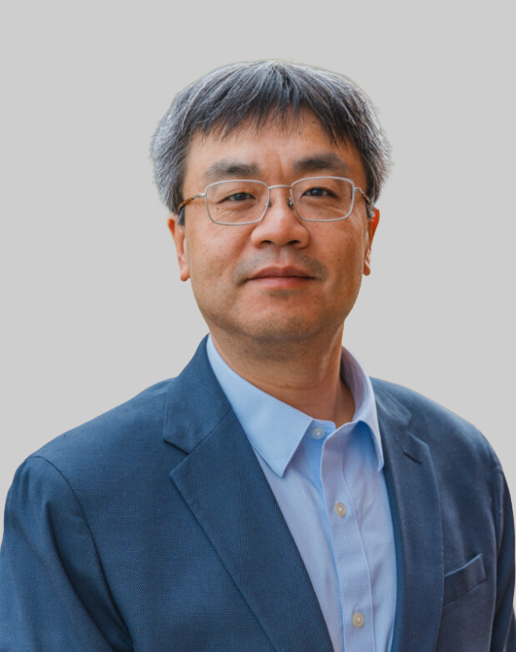
Dr. Feng Zhao --- Professor
Dr. Chen Zhu --- Associate Research Professor

